Improving ECG-Based Arrhythmia Classification with Principal Component Analysis and Machine Learning
Huu Cam Nguyen, Hai-Long Nguyen, Hai-Chau Le, and Quang Anh Tran
Posts and Telecommunications Institute of Technology, Hanoi, Vietnam

Abstract: Cardiovascular diseases (CVDs) remain a leading cause of global mortality, particularly in developing regions where access to advanced diagnostic infrastructure is limited. Electrocardiograms (ECGs), especially 12-lead recordings, play a critical role in detecting cardiac arrhythmias. However, the high dimensionality of ECG data poses computational challenges for real-time and resource-efficient analysis. In this study, we propose an effective approach that integrates Principal Component Analysis (PCA) for dimensionality reduction with multiple machine learning models for arrhythmia classification. PCA is employed to extract the most informative features from the original 12-lead ECG signals, significantly reducing redundancy and training time without compromising diagnostic performance. We evaluate our method using the Chapman University dataset, which includes over 10,000 annotated 12-lead ECG recordings representing four key arrhythmia types. Experimental results demonstrate that the proposed PCA-based feature selection strategy, when combined with models such as Random Forest, XGBoost, and Support Vector Machine, achieves classification accuracy exceeding 97%, with strong precision and recall. The obtained results confirm the potential of PCA-enhanced machine learning as a scalable and accurate solution for automated arrhythmia detection in clinical and mobile health applications.
Keywords: Machine learning, Principal Component Analysis, Feature selection, Electrocardiogram, Arrhythmia Classification.

Introduction
In the context of rapidly advancing healthcare, issues related to human health, mainly cardiovascular diseases, have collected significant attention. Despite meaningful progress in diagnostic and treatment technologies, the prevalence and mortality rates associated with heart diseases remain alarmingly high. A study by the American Heart Association estimates that by 2035, approximately 45% of the US population. the population will suffer from some form of cardiovascular disease, with the total cost of treatment projected to reach nearly $1 trillion [1]. According to the World Health Organization (WHO), cardiovascular diseases continue to be the leading cause of death worldwide, accounting for about 32% of all deaths in 2019, with over 17.9 million lives lost that year [2]. This situation is even more severe in developing countries, where limited healthcare infrastructure and resources, combined with a lack of awareness about risk factors, have made cardiovascular diseases harder to control and treat effectively [3]. The main reason is the delayed detection and intervention, often due to insufficient medical resources and a shortage of specialized healthcare professionals [4][5].
To solve these challenges, Machine Learning (ML) has been extensively researched and applied in the medical field. ML not only assists in cardiovascular diagnosis but is also widely used in other domains such as brain anomaly detection, biomedical signal processing, and clinical decision support. In cardiology, ML facilitates the rapid and accurate detection of abnormalities from medical data, contributing to reduced mortality rates and improved treatment outcomes [6].
One of the most significant applications of ML in cardiology is the analysis of electrocardiograms (ECG), a non-invasive method used to record the electrical activity of the heart through electrodes placed on the skin. ECG plays an important role in diagnosing conditions such as arrhythmias, myocardial infarction, heart failure, and electrolyte imbalances, providing clinicians with rapid and reliable insights [6][7].
Currently, many kinds of ECG systems exist, differing in the number of leads used. Among them, the 12-lead ECG is considered the gold standard in cardiovascular diagnostics. Compared to 1-lead or 3-lead systems, the 12-lead ECG provides a comprehensive view of the heart’s electrical activity from multiple angles, enabling machine learning algorithms to extract more informative features [8]. This leads to higher diagnostic accuracy, particularly for complex conditions like arrhythmias, acute myocardial infarction, and long QT syndrome.
Traditionally, confirming a diagnosis often requires combining ECG data with additional tests such as echocardiography, coronary angiography, or biochemical assays. However, recent studies have shown that ML models can diagnose heart conditions solely based on 12-lead ECG data, without the need for supplementary tests. This reduces diagnostic time and enhances automation in critical care scenarios [8][9].
In contrast to these advancements, several challenges remain in applying ML to ECG analysis. These include signal noise, biological variability among patients, and the scarcity of accurately labeled data [10]. A recent study using the Chapman dataset, which contains 10 seconds, 12-lead ECG recordings from 10,646 patients, sampled at 500 Hz, showed that although the models achieved high accuracy [11], processing the full 12-lead data could introduce computational issues. The large volume of parallel data may contain redundant or noisy features, leading to longer processing times and reduced model efficiency.
To tackle these issues, this study proposes the use of Principal Component analysis (PCA) for dimensionality reduction. PCA helps eliminate less informative features, reducing model complexity while preserving crucial information from the 12-lead ECG signals. Experimental results demonstrate that this approach accelerates processing, decreases computational load, and maintains high diagnostic accuracy. This research not only enhances the performance of ML models in ECG analysis but also opens new possibilities for integrating such methods into automated diagnostic systems and smart medical devices, contributing to the early and effective detection of cardiovascular diseases.

DATA PROCESSING
In this study, we use a dataset developed by Chapman University in collaboration with Shaoxing People's Hospital and Ningbo First Hospital, which serves as our primary data source [11]. This dataset is considered one of the most comprehensive ECG datasets and has been widely adopted in arrhythmia diagnosis research, achieving high accuracy in numerous international studies. Its extensive use highlights its comprehensiveness and its value in the development of cardiovascular diagnostic support systems. The dataset contains 10 seconds, 12-lead ECG recordings from 10,646 patients, sampled at 500 Hz. It includes annotations by expert clinicians for 11 common cardiac rhythms and 67 additional cardiovascular conditions. The dataset contains ECG recordings of various durations, collected from patients at a sampling rate. Each ECG record consists of 12 leads and is labeled with heart rhythm annotations by medical professionals.
Before applying Principal Component Analysis (PCA) for dimensionality reduction, we processed the ECG signals using NeuroKit2, a powerful library for extracting physiological features from biosignals[13]. From each ECG lead, we extracted 20 key features, including heart rate parameters, signal statistics, wave amplitudes, and phase ratios of the cardiac cycle. After feature extraction, we applied PCA to select and reduce the number of leads, retaining only those that contribute the most to the model. Because the dataset has already been reviewed and preprocessed, we were able to use it directly with the library without prior denoising. After PCA, each lead is represented by [IDK] features, reducing redundancy and optimizing model performance.
To simplify the classification, expert professionals grouped the labeled heart rhythms in the dataset into major categories, such as AFIB (Atrial Fibrillation and Atrial Flutter), SB (Sinus Bradycardia), SR (sinus Rhythm), and GSVT (General Supraventricular Tachycardia) [14]. All feature data were normalized using MinMaxScaler, scaling values to the range [0, 1] to ensure consistency before applying PCA and to maintain stability during model training.
To reduce the complexity of the data while still retaining the features that influence classification, we applied PCA to perform variance-based dimensionality reduction. We chose PCA because it has better performance compared to other dimensionality reduction techniques. After dimensionality reduction, the data were fed into seven different machine learning models. The results were then evaluated to identify the most optimal model for arrhythmia classification.

Methodology
Figure 1 describes the workflow of our proposed method. After the data have been preprocessed as described in section 2, we apply Principal Component Analysis (PCA) to reduce the dimensionality. PCA helps us retain only the most significant features by selecting components based on their variance. This not only preserves important information but also reduces the number of features for training. The processed data are then split into training and testing sets. The training set is used as input for six different AI models, and we apply 3-fold cross-validation to evaluate their performance during training. Finally, the testing set is used to assess the overall performance of the models.

The detailed implementation of each step is presented in the subsection below.
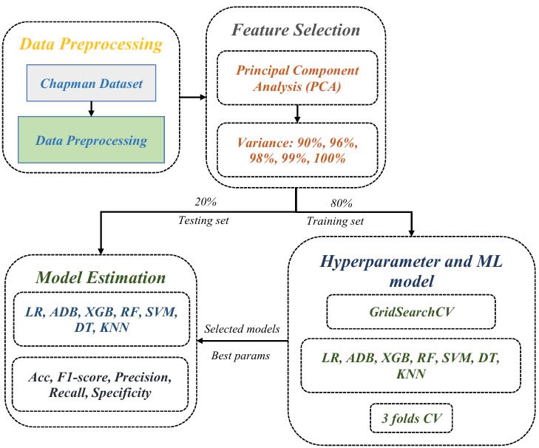
Fig.1: Workflow of the ECG arrhythmia prediction using PCA and machine learning models.

Feature Selection using Principal Component Analysis (PCA)
In this research, we used Principal Component Analysis (PCA) - a technique used to reduce the dimensionality of datasets while increasing interpretability and minimizing information loss. PCA works by identifying new variables, called principal components, which are derived from the original data through the solution of an eigenvector problem. These components are not defined a priori but are instead determined by the data itself, making PCA an adaptive data analysis technique [15, 18]. PCA performs linear dimensionality reduction using Singular Value Decomposition (SVD) to project data into a lower-dimensional space [16]. Dimensionality reduction is the process of reducing the number of variables under, and it plays a key role in extracting features from raw datasets or simplifying data while preserving its structure [17]. In machine learning pipelines, it is often used to improve generalization, reduce overfitting, and decrease computation time.
To determine the optimal number of principal components to retain, we applied a variance-based thresholding approach, a widely used method in dimensionality reduction tasks [15,16, 18]. Specifically, we evaluated five cumulative explained variance thresholds: 90%, 95%, 96%, 98%, and 99%. For each threshold, we selected the smallest number of components required to reach or exceed the target cumulative variance [16, 18]. This way offers a more flexible and data-driven alternative to the traditional eigenvalue-one criterion, which retains components with eigenvalues greater than 1.0 [15]. In contrast, variance thresholding allows finer control over the amount of information preserved and better adapts to the structure of each dataset. The PCA-transformed datasets corresponding to each threshold were subsequently used for model training and evaluation to assess their impact on classification performance.
In ECG analysis, it is essential to preserve a high proportion of the original variance to ensure that subtle but diagnostically significant features are not lost [19, 20]. Previous studies have shown that selecting too few components can exclude essential physiological patterns, while retaining too many components may introduce redundancy or noise [15, 18]. Conversely, using fewer components (e.g., 90–95%) can reduce training time and the risk of overfitting, especially in smaller or noisier datasets [16,17].
Ultimately, the final selection of the number of principal components was based on empirical performance observed during cross-validation across the different threshold settings [16].

Model Estimation
Before applying machine learning models and evaluating the effectiveness of the PCA method, we divided the dataset into two subsets: 70% for training and 30% for testing. To assess the impact of PCA on classification performance, we selected seven well-known machine learning algorithms that represent a range of learning strategies, are widely used in practice, and are known for their efficiency. Below is a brief description of each model.
AdaBoost (ADA) is an ensemble method that combines multiple weak learners into a strong classifier. It works by iteratively adjusting the weights of training instances, placing more focus on those that were misclassified in previous rounds. The final prediction is a weighted vote of all the learners, offering strong performance across various tasks.
Decision Tree (DT) is a rule-based model that splits the dataset into branches based on feature thresholds, forming a tree-like structure. It is easy to interpret but can suffer from overfitting, especially with noisy or complex data.
k-Nearest Neighbors (KNN) is a lazy learning algorithm that makes predictions by identifying the k most similar instances in the training set. It classifies a new input based on the majority label among its nearest neighbors, measured by distance in the feature space.
Logistic Regression (LR) is a probabilistic model that maps input features to output probabilities using a sigmoid function. It is suitable for binary classification tasks and assumes a linear relationship between the input variables and the log-odds of the target variable.
Random Forest (RF) is an ensemble of decision trees trained on different subsets of the data and features. This method reduces variance and helps avoid overfitting, making it robust even when working with high-dimensional datasets.
Support Vector Machine (SVM) is a margin-based classifier that attempts to find the optimal hyperplane separating different classes. It can model non-linear boundaries by using kernel functions, which makes it effective in complex classification tasks.
XGBoost (XGB) is a gradient boosting framework known for its speed and accuracy. It builds decision trees sequentially, where each new tree corrects errors from the previous ones. XGBoost also includes regularization techniques to control overfitting and supports parallel computation for scalability.
Each of the seven classifiers was run multiple times. In this study, we employed 3-fold cross-validation to evaluate the performance of each model more accurately and to reduce the risk of performance variability due to data partitioning. For each algorithm, the best-performing result—in terms of classification accuracy—was selected for reporting. Classification accuracy, defined as the percentage of correctly predicted labels in the test set, was used as the primary performance metric.

Evaluation Process
To assess the performance of the classification models, a confusion matrix was constructed for each model. This matrix provides a clear and comprehensive summary of the model's predictions by categorizing them into four outcomes:
True Positive (TP): Cases where patients with heart disease were correctly identified.
True Negative (TN): Cases where patients without heart disease were correctly identified.
False Negative (FN): Cases where patients with heart disease were incorrectly classified as healthy.
False Positive (FP): Cases where healthy patients were incorrectly classified as having heart disease.
In the context of medical diagnosis, false negatives are considered particularly critical, as they may lead to missed diagnoses and delayed treatment. Based on these values, a set of performance metrics was calculated to provide a more nuanced evaluation of each model’s classification capability.
Accuracy (ACC) measures the overall proportion of correctly classified instances, both positive and negative
Accuracy= $\frac{TP+TN}{TP+TN+FP+FN}$

Precision indicates the proportion of true positive predictions among all predicted positive cases. It reflects how reliable the model is when it predicts a positive result
Precision= $\frac{TP}{TP+FP}$
Recall (Sensitivity) represents the ability of the model to correctly identify all actual positive cases (patients with heart disease). It is particularly important in the medical context, where missing a true positive (false negative) can have severe consequences
Recall= $\frac{TP}{TP+FN}$
F1-score is the harmonic mean of precision and recall, providing a balance between the two, especially useful when the dataset is imbalanced
F1-score= $2\left(\frac{\operatorname{Pr}{e}cision.Recall }{\operatorname{Pr}{e}cision+Recall}\right)$
Specificity measures the model's ability to correctly identify negative cases (patients without heart disease), helping to avoid false alarms
Specificity= $\frac{TN}{TN+FP}$
By analyzing these metrics together, we obtain a comprehensive view of each model’s performance. Recall and specificity are important in medical diagnosis tasks to minimize the risk of undiagnosed cases and unnecessary treatment, respectively. All metrics were computed after applying 3-fold cross-validation to ensure the robustness and generalizability of the models.

EXPERIMENTAL RESULTS AND DISCUSSION

Results
To evaluate the effectiveness of Principal Component Analysis (PCA) in distinguishing different types of arrhythmias from 12-lead ECG signals, we trained and tested seven machine learning (ML) models independently. Each model was tasked with classifying the signals into four categories: Atrial Fibrillation (AFIB), Sinus Bradycardia (SB), Sinus Rhythm (SR), and Supraventricular Tachycardia (GSVT). The models were trained using the training dataset and later evaluated on the test set to assess their classification performance.
Before classification, PCA was applied to reduce the dimensionality of the ECG data while retaining the most informative features. As shown in Fig.2, the first few principal components explain a large proportion of the variance, with the first component capturing the majority. After the third component, the explained variance drops off sharply. This suggests that a small number of principal components, particularly the first three, are sufficient to retain most of the essential information from the original dataset.
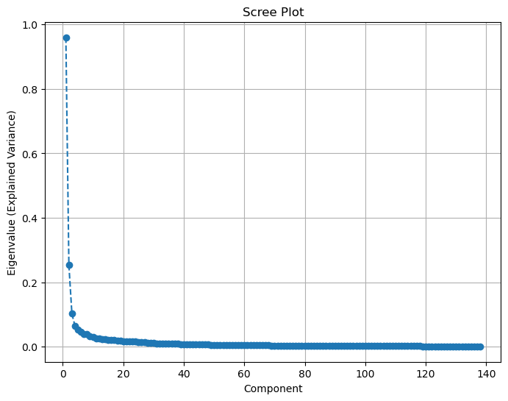
Fig.2: Scree Plot
Figure 3 provides a 3D scatter plot of the data projected onto the first three principal components. These components were selected based on the scree plot (Figure 2), which showed they capture the most significant variance in the dataset.
As shown in the plot, the majority of data points are concentrated in a relatively compact region of the 3D space, indicating that PCA has captured the underlying structure of the ECG signals. The overall distribution demonstrates potential for effective separation of classes using the reduced feature space. There is partial separation between some classes, especially between AFIB (red) and the other rhythm types. Although some overlap exists—particularly among SR, SB, and GSVT—these clusters still exhibit internal consistency, suggesting that class-specific information is retained even after dimensionality reduction.
After applying Principal Component Analysis (PCA) to reduce the dimensionality of the data, multiple classification models were evaluated on the test dataset. The figure 4 shows the average accuracy of each model across different levels of retained variance representing how much information from the original data is preserved after PCA.
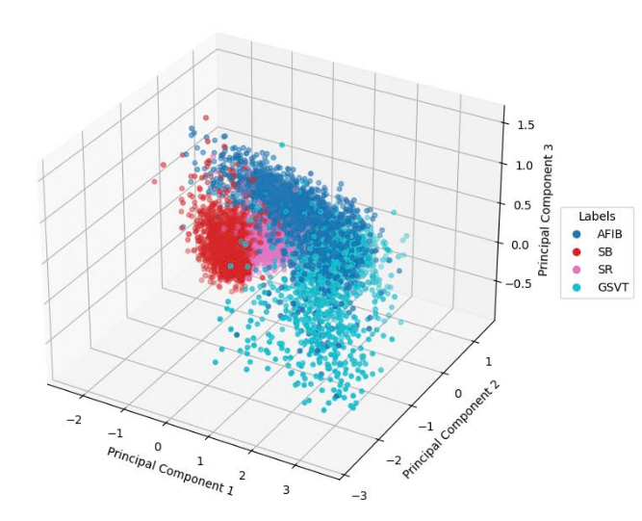
Fig.3: PCA 3D Scatter Plot
From the figure, it is clear that models such as Random Forest, XGBoost, and SVM consistently yield high accuracy, with scores remaining above 0.96 across different configurations. In contrast, the Decision Tree (DT) model shows significant variability, with accuracy dropping below 0.80 in some cases. AdaBoost delivers more stable results than DT, but still behind the top-performing models.
As the retained variance in PCA decreases, the number of features is also reduced. Despite this reduction, top-performing models—particularly RF, XGBoost, and SVM—still maintain high accuracy. This indicates that applying PCA not only reduces the dimensionality of the data but also retains the most relevant features, enabling efficient and robust classification. In contrast, the DT model tends to overfit that enhance generalization in other models, which explains its lower and more fluctuating accuracy. Overall, these findings suggest that tree-based and margin-based classifiers like RF, XGBoost, and SVM are more reliable for ECG arrhythmia classification, as they are better able to capture the underlying patterns in the data.
In addition, the classification performance of several individual machine learning models—including AdaBoost (Ada), Decision Tree (DT), K-Nearest Neighbors (KNN), Logistic Regression (LR), Random Forest (RF), Support Vector Machine (SVM), and XGBoost (XGB)—was evaluated in terms of accuracy across the four arrhythmia categories: Atrial Fibrillation (AFIB), Sinus Bradycardia (SB), Sinus Rhythm (SR), and Supraventricular Tachycardia (GSVT), as shown in Figure 4.
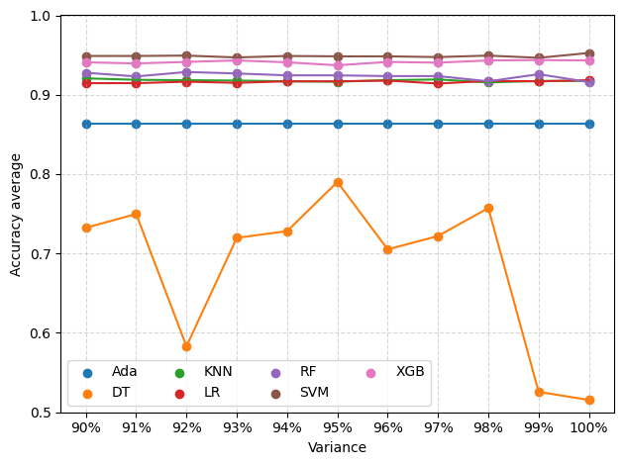
Fig.4: Accuracy comparison for each model with each variance
To provide a more comprehensive evaluation, Table I presents the detailed classification results for each of the four arrhythmia categories—AFIB, SB, SR, and GSVT—across all the machine learning models. The metrics compares accuracy mean of 4 classes AFIB, SB, SR, GSVT between without using PCA and using PCA to extract the most informative features for classification.
TABLE I
ACCURACY COMPARISION

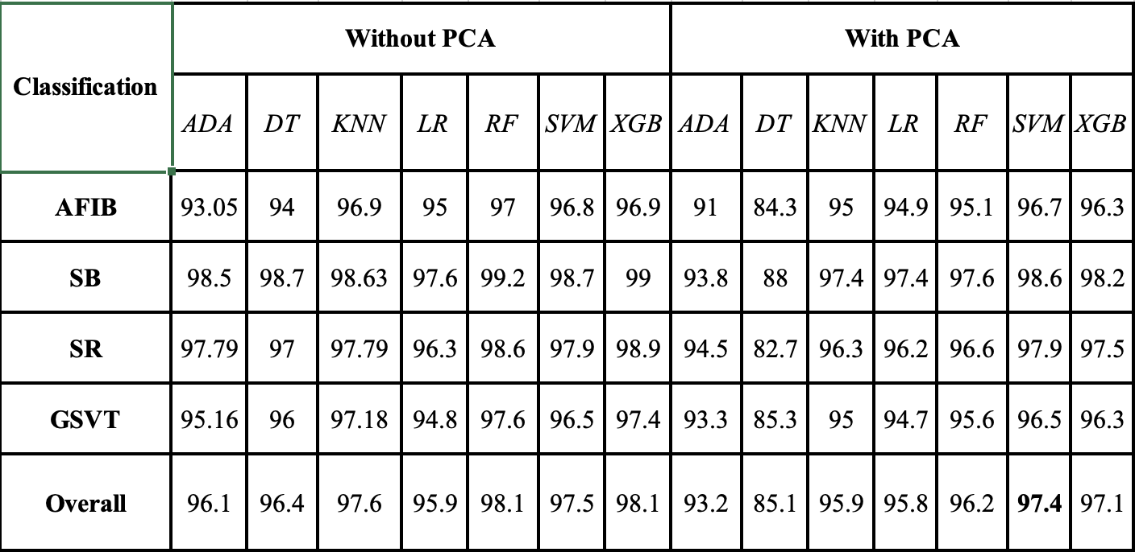
To provide a more comprehensive evaluation, we assessed the performance of the models using various metrics, including Accuracy, F1-score, Precision, Recall, Specificity, as well as the number of PCA components and their corresponding features, as presented in Table II below.
TABLE II
Comparison of Classification Model Performance Based on Optimal PCA Values
 | Best PCA Value | Accuracy (%) | F1-score (%) | Precision (%) | Recall (%) | Specificity (%) | Features After PCA
ADA | 0.91 | 93.2 | 84.6 | 86.4 | 84.8 | 95.3 | 56
DT | 0.95 | 89.5 | 76.4 | 76.4 | 76.2 | 93.1 | 81
KNN | 0.92 | 96.3 | 94.1 | 90.6 | 92.2 | 96.8 | 61
LR | 0.95 | 96.2 | 90.6 | 93.0 | 91.7 | 97.6 | 81
RF | 0.92 | 96.4 | 91.8 | 92.5 | 92.0 | 97.6 | 61
SVM | 0.93 | 97.5 | 94.3 | 94.4 | 94.4 | 98.3 | 61
XGB | 0.93 | 97.2 | 93.6 | 93.9 | 93.7 | 98.1 | 67

As shown in the results above, the best PCA values between 0.9 and 0.95, where the original 212 features were reduced between 56 to 81, respectively. Despite this reduction, the evaluation metrics remain high, demonstrating not only the effectiveness of the model but also improved efficiency in terms of resource usage.

TABLE III
F1-Score results for each model with each variance
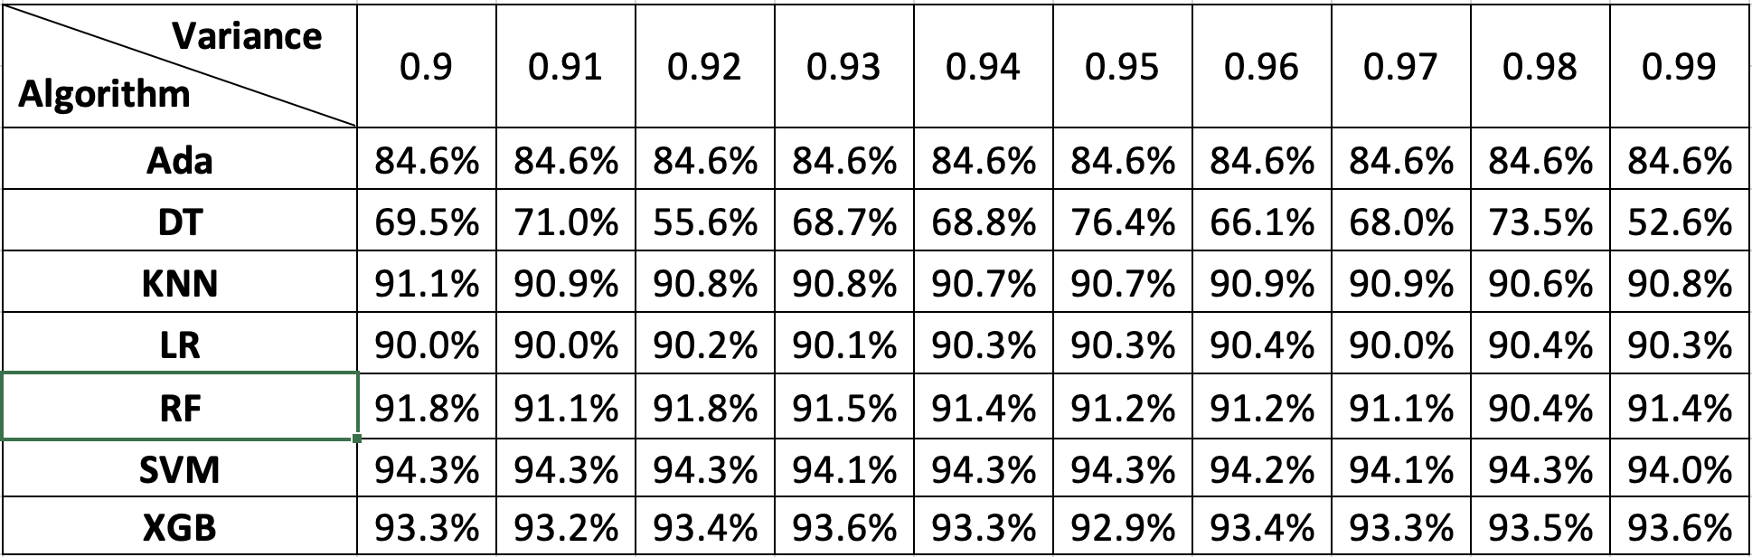
Based on these results, it is evident that the application of Principal Component Analysis (PCA) effectively reduces the dimensionality of the ECG dataset while preserving its essential characteristics. Despite the reduced feature space, the models still maintain high classification performance, which confirms that the most informative components were retained. This not only helps reduce computational resources but also enhances the efficiency and scalability of the models in practical settings.

Discussion
In this study, Principal Component Analysis (PCA) was applied as a dimensionality reduction technique to enhance the efficiency of classifying 12-lead ECG signals into four arrhythmia categories: Atrial Fibrillation (AFIB), Sinus Bradycardia (SB), Sinus Rhythm (SR), and Supraventricular Tachycardia (GSVT). The results across multiple machine learning models demonstrate that PCA is an effective preprocessing step in the arrhythmia classification pipeline.

The scree plot and 3D scatter plot of the principal components reveal that the first few components—particularly the first three—capture the most significant variance in the data. The visualization clearly shows a compact clustering of data points in the reduced feature space, indicating that key structural information is preserved even after dimensionality reduction. This suggests that PCA helps maintain the class separability required for effective classification. Models such as SVM, XGB, and RF delivered superior performance with values reaching up to 0.98, while others like LR and KNN maintained strong and stable results around 0.96. Even with dimensionality reduction, these classifiers demonstrated robust generalization. In contrast, performance fluctuations in DT suggest limited adaptability in simplified feature representations.

The detailed performance metrics for each arrhythmia class further confirmed the robustness of PCA-processed data. Models like RF and XGB not only maintained high accuracy but also achieved balanced precision, recall, and F1-scores across all four classes. This indicates strong discriminative capability, even in a compact feature space. Meanwhile, simpler models such as Logistic Regression (LR) and K-Nearest Neighbors (KNN) also showed competitive performance, albeit slightly lower, reinforcing the idea that PCA benefits a wide range of classifiers.

These findings support the conclusion that PCA is highly effective for reducing the complexity of ECG datasets without sacrificing classification performance. This has practical implications for real-time or resource-constrained applications, where computational efficiency is essential. By minimizing data redundancy while retaining critical features, PCA helps reduce memory and processing requirements, allowing models to operate faster and more efficiently. Moreover, it can improve model interpretability and generalizability, especially in medical settings where transparency and reliability are crucial.

Conclusion
This study demonstrates the effectiveness of Principal Component Analysis as a dimensionality reduction technique for improving the efficiency and performance of arrhythmia classification using 12-lead ECG signals. By eliminating redundant and less informative features, PCA significantly reduced the complexity of the dataset while preserving critical diagnostic information. The experimental results across seven machine learning models, particularly Random Forest, XGBoost, and Support Vector Machine, confirmed that high classification accuracy could be maintained even after substantial feature reduction, with some models achieving performance levels exceeding 97%. The performance of models such as Decision Tree, however, highlighted the importance of aligning feature reduction strategies with the specific characteristics of each algorithm. While PCA generally improved computational efficiency and reduced training time, it also exposed certain limitations in algorithms sensitive to information loss. These experimental results suggest that dimensionality reduction must be applied judiciously, taking into account the inherent strengths and weaknesses of the underlying classifiers. The integration of PCA with machine learning offers a robust and scalable solution for ECG-based arrhythmia detection, particularly in resource-constrained or real-time clinical environments.
References
[1] American Heart Association, Cardiovascular Disease: A Costly Burden for America – Projections Through 2035, American Heart Association. Accessed: May 21, 2025. [Online]. Available: https://www.heart.org/-/media/Files/About-Us/Policy-Research/Fact-Sheets/Public-Health-Advocacy-and-Research/CVD-A-Costly-Burden-for-America-Projections-Through-2035.pdf
[2] World Health Organization (WHO), Cardiovascular Diseases (CVDs), WHO. Accessed: May 21, 2025. [Online]. Available: https://www.who.int/news-room/fact-sheets/detail/cardiovascular-diseases-(cvds)
[3] J. Liu, Z. Li, Y. Jin, Y. Liu, C. Liu, L. Zhao, and X. Chen, “A review of arrhythmia detection based on electrocardiogram with artificial intelligence,” Expert Review of Medical Devices, vol. 19, no. 7, pp. 549–560, 2022.
[4] National Institute for Health and Care Research (NIHR), Addressing the Challenge of Cardiovascular Diseases in Low and Middle-Income Countries, NIHR.
[5] G. A. Roth, G. Nguyen, M. H. Forouzanfar, A. H. Mokdad, M. Naghavi, and C. J. L. Murray, “Early Cardiovascular Disease Mortality Projections for 2025: Global and Regional Estimates,” Circulation, 2023. DOI: 10.1161/CIRCULATIONAHA.123.065717.
[6] Y. Li, Q. Zhang, Z. Wang, W. Wang, and M. Xu, “Application of Machine Learning Algorithms for Predicting the Risk of Cardiovascular Diseases: A Systematic Review,” Frontiers in Cardiovascular Medicine, vol. 8, 749313, 2021.
[7] R. Gupta and S. Sharma, “The Role of Artificial Intelligence in Cardiovascular Disease Prediction: A Comprehensive Review,” Frontiers in Cardiovascular Medicine, vol. 10, 938170, 2023.
[8] P. W. Macfarlane, A. Van Oosterom, O. Pahlm, P. Kligfield, M. Janse, and J. Camm, Comprehensive Electrocardiology, Springer Science & Business Media, 2010.
[9] Y. M. Ayano, F. Schwenker, B. D. Dufera, and T. G. Debelee, “Interpretable Machine Learning Techniques in ECG-Based Heart Disease Classification: A Systematic Review,” Diagnostics, vol. 13, no. 1, p. 111, 2023.
[10] C. T. Chung, S. Lee, E. King, T. Liu, A. A. Armoundas, G. Bazoukis, and G. Tse, “Clinical Significance, Challenges and Limitations in Using Artificial Intelligence for Electrocardiography-Based Diagnosis,” Frontiers in Cardiovascular Medicine, vol. 9, 853830, 2022.
[11] J. Zheng, J. Zhang, S. Danioko, H. Yao, H. Guo, and C. Rakovski, “A 12-lead Electrocardiogram Database for Arrhythmia Research Covering More Than 10,000 Patients,” Scientific Data, vol. 7, no. 1, p. 48, 2020.
[12] Nguyen, H.-L., Pham, V.-S., and Le, H.-C., “Blending Ensemble Learning for Enhanced Arrhythmia Classification Utilizing 12-Lead ECGs,” Computers, vol. 1, no. 0, 2024.
[13] D. Makowski, T. Pham, Z. J. Lau, J. C. Brammer, F. Lespinasse, H. Pham, C. Sch¨olzel, and S. A. Chen, “NeuroKit2: A python toolbox for neurophysiological signal processing,” Behavior Research Methods, vol. 53, no. 4, pp. 1689–1696, feb 2021. [Online]. Available
[14] D. S. Jianwei Zheng, Huimin Chu et al., “Optimal multi stage arrhythmia classification approach,” Scientific reports, vol. 10, no. 1, p. 2898, 2020.
[15] Jolliffe, I. T., & Cadima, J. (2016). Principal component analysis: A review and recent developments. Philosophical Transactions of the Royal Society A: Mathematical, Physical and Engineering Sciences, 374(2065), 20150202.
[16] Shlens, J. (2014). A Tutorial on Principal Component Analysis. arXiv preprint.
[17] Domingos, P. (2012). A few useful things to know about machine learning. Communications of the ACM, 55(10), 78–87.
[18] Jolliffe, I. T. (2002). Principal Component Analysis (2nd ed.). Springer Series in Statistics.
[19] Martis, R. J., Acharya, U. R., & Min, L. C. (2013). ECG beat classification using PCA, LDA, ICA and discrete wavelet transform. Biomedical Signal Processing and Control, 8(5), 437–448.
[20] Abdi, H., & Williams, L. J. (2010). Principal component analysis. Wiley Interdisciplinary Reviews: Computational Statistics, 2(4), 433–459.

